**A Project Report**

**On**

**" PASSWORD BASED HOME SECURITY "**

Submitted in Partial Fulfillment of the Requirement Of

Project-III (BIT206CO)

Of

Bachelor of Information Technology

**Submitted to:**



Purbanchal University

Biratnagar, Nepal

**Submitted by:**

Sagar Upadhyaya (333659)

Shubham Ghimire (333661)

Ashim Sapkota (333638)

**KANTIPUT CITY COLLEGE**

Putalisadak, Kathmandu

March 23, 2023

**A Project Report**

**On**

**" PASSWORD BASED HOME SECURITY "**

Submitted in Partial Fulfillment of the Requirement Of

Project III (BIT206CO)

Of

Bachelor of Information Technology

**Submitted to:**

Purbanchal University

Biratnagar, Nepal

**Submitted by:**

Sagar Upadhyaya (333659)

Shubham Ghimire (333661)

Ashim Sapkota (333638)

**Project Supervisor**

**Er. Rabi Shrestha**

**KANTIPUT CITY COLLEGE**

Putalisadak, Kathmandu

March 23, 2023

**CERTIFICATE OF TOPIC APPROVAL SHEET**

It is hereby informed that the topic selected by Sagar Upadhyaya, Shubham Ghimire, and Ashim Sapkota of BIT third semester project has been found suitable and as per the credit assigned by Purbanchal University (PU), Biratnagar, Nepal. The Project Committee has approved the following topic and supervisor for the mentioned students. This project has been completed for the prescribed period and the project embodied the result of their investigation conducted during they worked as full-time student of this institution.

Topic Approved: Password Based Home Security

_____________________ ______________________

Er. Saroj Pandey Er. Rabi Shrestha

HOD, Department of Information Technology Project Supervisor

Kantipur City College Kantipur City College

**CERTIFICATE FROM SUPERVISOR**

This is to certify that the project titled Password Based Home Security submitted by Sagar Upadhyaya, Shubham Ghimire, and Ashim Sapkota to the Department of Information Technology, School of Science and Technology at Kantipur City College, Kathmandu, Nepal towards the requirement for Project-III is an original work carried out by them under my supervision and guidance.

____________________

Er. Rabi Shrestha

Department of Information Technology

Kantipur City College

(Project Supervisor)

**ACKNOWLEDGEMENT**

We would like to acknowledge all who have encouraged and inspired us directly or indirectly to complete this project. At first, we desire to express our deepest sense of gratitude to Purbanchal University for giving us the opportunity to present ourselves this report within the scheduled time.

We want to thank Kantipur City College for providing this opportunity by approving our project. We are incredibly grateful to our supervisor Er. Rabi Shrestha for continuously supporting and guiding us in our project and providing his valuable time to complete our project.

We also are very thankful to rest of the teacher who were also helpful for providing us the idea to prepare this project and for continuously motivating us to focus on our project.

We are fortunate enough to get the encouragement and feedback from our teachers and friends. Lastly, many thanks to all the people for their suggestions, feedback and support which was the most in completing our project successfully.

This project has been a wonderful experience where we have learnt and experienced many beneficial things.

With regards

Sagar Upadhyaya

Shubham Ghimire

Ashim Sapkota

**ABSTRACT**

Password Based Home Security is a password-based door locking system which is a security solution that restricts access to a specific area by verifying the correct password entered by the user. The system is comprised of a keypad that prompts the user to enter a pre-set password, which is then verified. If the password is correct, the system grants access to the user, otherwise, the door remains locked.

This system offers a range of benefits over traditional key-based systems, including increased security, convenience, and flexibility. Passwords can be easily changed, and the system can be programmed to grant access only to authorized individuals. Overall, a password-based door locking system is an effective and reliable security solution that offers a high level of protection against unauthorized access. By using strong passwords and implementing appropriate security measures, this system can provide peace of mind to homeowners, businesses, and other organizations.

Table of Contents

CHAPTER 1: INTRODUCTION 1

1. Introduction 1

1.1 Project Background 1

1.2 Project Significance 2

1.3 Problem Solving Statement 2

1.4 Objectives 3

1.5 Features 3

1.6 Team structure and roles 3

CHAPTER 2: SYSTEM ANALYSIS 4

2.1 Literature Review 4

2.2 Feasibility Study 4

2.2.1 Technical Feasibility 4

2.2.2 Schedule Feasibility 4

2.2.3 Economic Feasibility 4

2.2.4 Operational Feasibility 4

2.3 Required Components 4

2.4 Applications of Password Based Door Lock System 9

2.5 Working Principle 9

CHAPTER 3: SYSTEM DESIGN 10

3.1 Block Diagram 10

3.2 Circuit Diagram 11

3.3 Flowchart 12

3.4 Keypad Working Principle 13

3.5 Gantt Chart 14

CHAPTER 4: SYSTEM DEVELOPMENT AND IMPLEMENTATION 15

4.1 Programing platform (Tools and technologies used) 15

4.1.1 Software Specifications 15

4.1.2 Hardware Specifications 15

CHAPTER 5: TESTING AND DEBUGGING 16

CHAPTER 6: CONCLUSION AND FUTURE ENHANCEMENT 17

6.1 Conclusion 17

6.2 Future enhancement 17

REFERENCES 18

APPENDIX 19

**LIST OF TABLES**

|  |  |  |
| --- | --- | --- |
| **Table no.** | **Table name** | **Page no.** |
| 1 | Team structure and role | 3 |
| 2 | Gantt chart | 14 |
| 3 | Testing and debugging | 16 |

**List of Figure**

|  |  |  |
| --- | --- | --- |
| **Figure no** | **Figure name** | **Page no** |
| 1 | 8051 microcontroller | 6 |
| 2 | Keypad 4x4 | 7 |
| 3 | Electric lock | 7 |
| 4 | LCD 16x2 | 8 |
| 5 | Block diagram | 10 |
| 6 | Circuit diagram | 11 |
| 7 | Flow chart | 12 |
| 8 | Keypad working | 13 |

# CHAPTER 1: INTRODUCTION

## 1. Introduction

Password Based Door Lock System using 8051 Microcontroller is a simple project where a secure password will act as a door unlocking system wherein once the correct code or password is entered, the door is opened, and the concerned person is allowed access to the secured area. If the password is wrong, then door would remain closed, denying access to the person.

## 1.1 Project Background

The need for security and access control has become increasingly important in today's society, with businesses, organizations, and homeowners seeking reliable and efficient solutions to safeguard their properties and assets. Traditional key-based locking systems have proven to be vulnerable to theft, tampering, and duplication, prompting the development of more sophisticated and advanced security measures such as biometric authentication, smart cards, and password-based systems.

A password-based door locking system is a popular security solution that has gained popularity due to its ease of use, flexibility, and reliability. The system uses a pre-set password to grant access to authorized users while denying entry to unauthorized individuals. This system is particularly useful for businesses and organizations that need to restrict access to sensitive areas such as data centers, server rooms, and confidential files.

The project aims to design and implement a password-based door locking system that can provide a high level of security and access control. The system will be designed to be user-friendly, reliable, and easy to maintain, using readily available components and technologies.

The project involves several stages, including research, design, testing, and implementation. The system is tested extensively to ensure that it meets the required standards and specifications.

Overall, the project will provide a valuable contribution to the field of security and access control, providing a reliable and efficient solution for businesses and organizations that need to protect their assets and sensitive information.

## 1.2 Project Significance

The password-based door locking system is a highly significant project with several important implications for the field of security and access control. Some of the most notable significance of this project include:

1. Improved Security: Password-based door locking systems provide a higher level of security than traditional key-based systems. This is because passwords can be easily changed and restricted to authorized users only, making it difficult for unauthorized individuals to gain access.
2. Convenience: Password-based systems are convenient to use since users do not need to carry keys around with them. Additionally, users can easily change their passwords when necessary, making it easy to maintain access control.
3. Cost-Effective: Password-based systems are cost-effective since they do not require expensive hardware or software. This makes them a practical solution for small businesses and homeowners.
4. Flexibility: Password-based systems are highly flexible and can be customized to meet the specific needs of individual users. For instance, passwords can be programmed to allow access to specific areas only or at specific times of the day.

## 1.3 Problem Solving Statement

Many building’s, rooms require a secure door locking system to prevent unauthorized access. Traditional lock-and-key systems have limitations and can be easily compromised. To address this problem, a password-based door locking system can be implemented. However, the challenge is to design a system that is both secure and user-friendly, with an easy-to-use interface for setting and entering the password. The system should also be reliable, durable, and cost-effective to implement and maintain. Therefore, the problem statement is to design and develop a password-based door locking system that addresses these challenges and meets the security requirements.

## 1.4 Objectives

* To provide genuine security :

The primary objective of a password-based door locking system is to provide security by allowing access only to authorized individuals who know the correct password. This prevents unauthorized access and helps to protect the contents of the building or room.

* To digitalize the locking system :

Password-based door locking systems are often more convenient than traditional key-based systems, as users do not need to carry physical keys or worry about losing them. Instead, they only need to remember their password.

## 1.5 Features

* Secure password will act as a door unlocking system
* LCD display shows if the access is granted or not
* Multiple user support
* Buzzer makes alarming sound if wrong code entered

## 1.6 Team structure and roles

|  |  |
| --- | --- |
| **Team Members** | **Task Performed** |
| Sagar Upadhyaya | Coding, Debugging and Hardware implementation |
| Shubham Ghimire | Logic development, Coding & Debugging, Research and Design |
| Ashim Sapkota | Research & Design and hardware implementation |

# CHAPTER 2: SYSTEM ANALYSIS

## 2.1 Literature Review

During our research we found some door locking project that has already been developed which varies in their working mechanism. Some were password based, some of them worked on fingerprint sensor, some worked on Movement Sensor, message verification and so on. But after overall research we choose to develop password based door locking system that suits our academic project using 8051 microcontroller.

Project References: Door Locking System

## 2.2 Feasibility Study

In a feasible study we performed feasibility analysis of a current system and the proposed system. Feasibility study is done in our project to identify the deficiencies in the current system and find the objective of the proposed system. There are many types of study that we have considered in our project. Following are the major study we performed while developing this project.

### 2.2.1 Technical Feasibility

Here we analyze the technical aspects of the project. The various technical aspects such as hardware and software were taken into consideration while developing this project. Further we also make sure that this software is feasible for the person who uses it.

### 2.2.2 Schedule Feasibility

In this feasibility study we prepared our planned Gantt chart according to our development model.

### 2.2.3 Economic Feasibility

Here we deal with the cost benefit of the project. Since this project is developed to meet our academic project, therefore there is no any refund.

## 

### 2.2.4 Operational Feasibility

We develop this project with the minimum hardware specification tm make this project of low cost and affordable. The user will enjoy with this system which is easy to understand and operate by few steps.

## 2.3 Required Components

* 8051 Microcontroller
* 8051 Development Board
* 8051 Programmer
* 4×4 Matrix Keypad
* 16×2 LCD
* Electric Lock
* 10KΩ Potentiometer
* Connecting wires
* Power Supply
* 8051 Microcontroller

The 8051 microcontroller is an 8-bit microcontroller that was first introduced in 1980 by Intel. It has been widely used in a variety of embedded systems, including automotive, industrial, medical, and consumer electronics applications.

The 8051 microcontroller is based on a Harvard architecture, which means that it has separate memory spaces for program code and data. It has a simple and efficient instruction set with 111 instructions that operate on 8-bit data.

The basic features of the 8051 microcontroller include:

1. 4 KB of on-chip ROM (read-only memory) for program code storage.

2. 128 bytes of on-chip RAM (random-access memory) for data storage.

3. Four 8-bit I/O ports for connecting to external devices.

4. Two 16-bit timer/counters for timing and counting applications.

5. A serial communication interface (UART) for serial communication.

6. Interrupt control circuitry for handling external and internal interrupts.

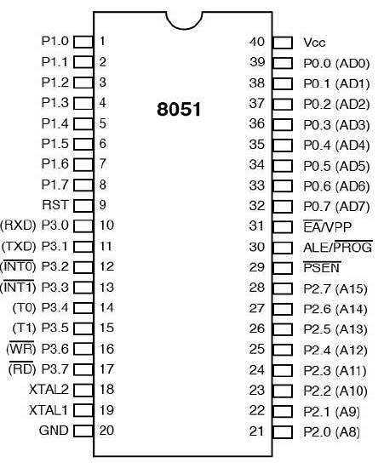

* 4*4 Matrix Keypad

A 4x4 matrix keypad is a commonly used input device in electronics projects, which provides a simple way to get user input. It consists of a 4x4 grid of buttons, with each button corresponding to a unique combination of row and column. Here's how it works:

Each button is connected to a specific row and column of the matrix. When a button is pressed, it creates a connection between the corresponding row and column lines. By scanning through each row and checking which column lines are connected, the microcontroller can determine which button was pressed.

To use a 4x4 matrix keypad with a microcontroller, you need to connect the row and column lines to the microcontroller's GPIO pins. You can then use software to scan through the rows and check which column lines are connected to detect which button was pressed.

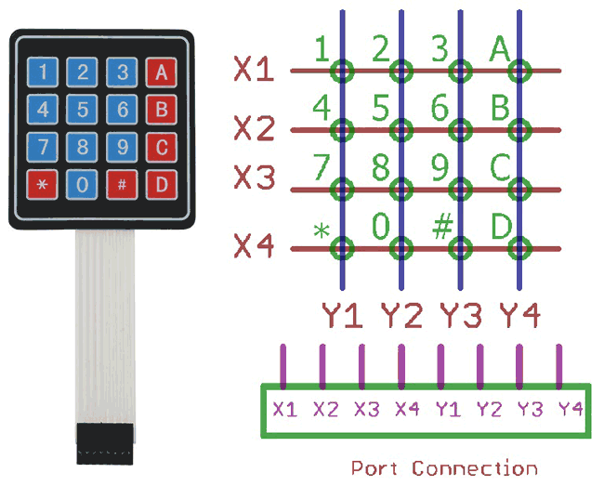

* Electric Lock

An electric lock is a type of lock that can be operated using an electrical current. It's commonly used in access control systems, such as in homes, offices, and other secure areas.

To use an electric lock, you need to install it in the door frame and connect it to a power source, such as an electrical outlet or battery. You also need to connect it to a control system, such as a keypad to control when the lock is activated.

Overall, electric locks provide a convenient and secure way to control access to a space, and can be a good option for home or business security.

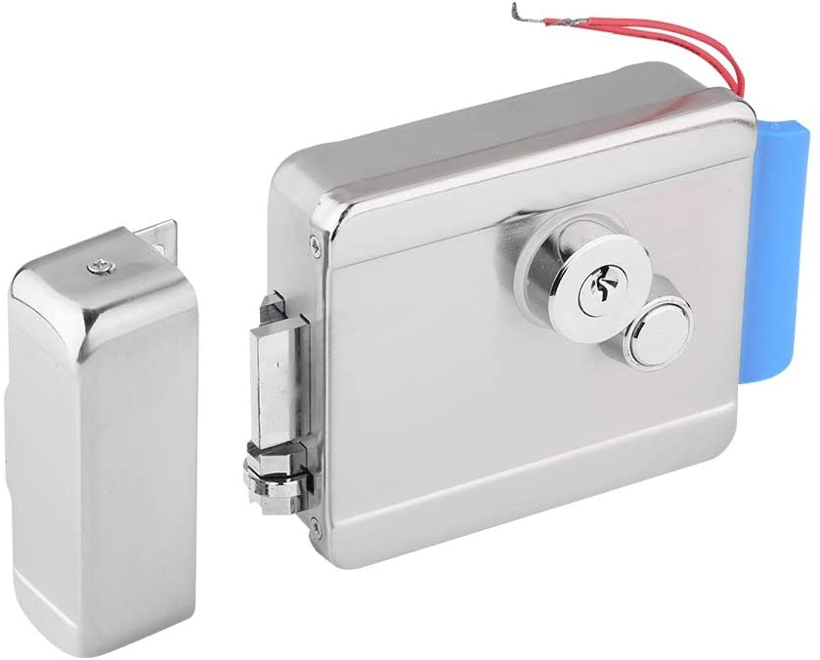

* 16*2 LCD

A 16*2 LCD (Liquid Crystal Display) is a type of alphanumeric display that can display 16 columns and 2 rows of characters. Each character is made up of a matrix of pixels that can be turned on or off to create the desired character or symbol.

To use a 16*2 LCD, you typically need to connect it to a microcontroller that will send it the necessary data and commands to display the desired characters or symbols. The LCD itself typically has a built-in controller chip that handles the low-level details of driving the individual pixels, so you don't need to worry about the details of how the display works.

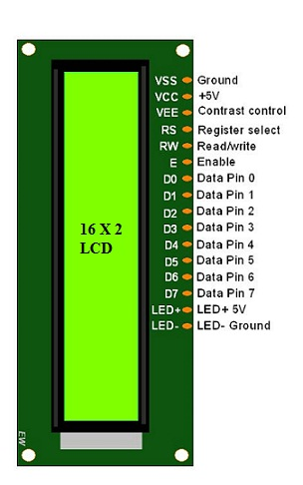

## 2.4 Applications of Password Based Door Lock System

Password-based door locking systems have a wide range of applications in various fields such as :

1. Residential: Password-based door locking systems can be used in homes to provide a convenient and secure way for homeowners to enter their homes without needing to carry a physical key.
2. Commercial: Many businesses use password-based door locking systems to control access to their buildings or specific areas within the building, such as storage rooms or employee-only areas.
3. Educational: Schools and universities use password-based door locking systems to secure classrooms, laboratories, and other areas within the campus.
4. Healthcare: Password-based door locking systems can be used in healthcare settings, such as hospitals or clinics, to control access to sensitive areas, such as patient records or medication storage rooms.
5. Hospitality: Hotels and resorts use password-based door locking systems to provide secure access to guest rooms and other areas within the facility.
6. Government: Password-based door locking systems are used in government buildings to control access to secure areas, such as offices or data centers.
7. Industrial: Password-based door locking systems can be used in industrial settings, such as factories or warehouses, to control access to equipment or inventory storage areas.

Overall, password-based door locking systems are a versatile and secure solution for controlling access to various types of buildings and areas.

## 2.5 Working Principle

* The main component in the circuit is 8051 controller. In this project, a 4×4 Matrix Keypad is used to enter the password.
* If entered password is matched with the pre stored data of the memory of the microcontroller then electric lock will function to run in a specific direction required for opening the door
* If the entered password doesn’t match with the pre stored password then the door remains locked and the buzzer makes alarming sound.

# CHAPTER 3: SYSTEM DESIGN

## 3.1 Block Diagram

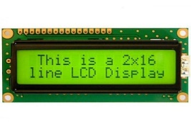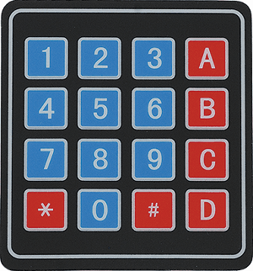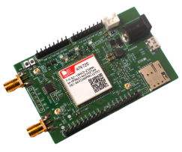

**8051 MICROCONTROLLER**

**4*4 KEYPAD**

**2*16 LCD DISPLAY**

**GSM MODULE**

**BUZZER**

**Electric Lock**

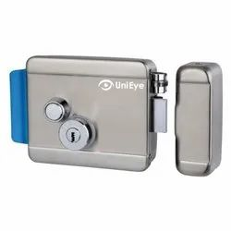

## 3.2 Circuit Diagram

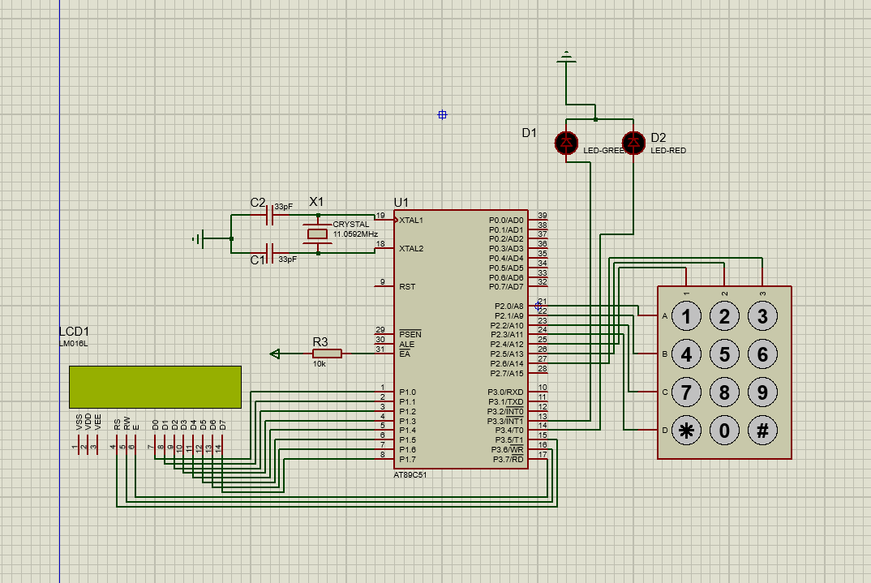

## 3.3 Flowchart

Start

Predefined Password

Read Keypad Password

Checks

Buzzer On

Serve Off

Door Unlock

Serve On

Unlock Allert

Send To Owner

Serve On

Security Allert

Send To Owner

Allert

Send To Owner

Security Allert

Send To Owner

End

**True**

**False**

## 3.4 Keypad Working Principle

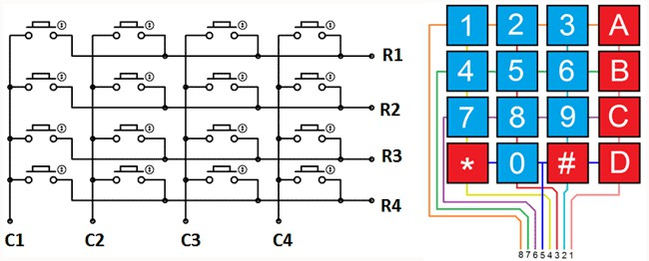

## 3.5 Gantt Chart

|  |  |  |  |  |  |  |
| --- | --- | --- | --- | --- | --- | --- |
| Task Name | 2022-2023 | | | | | |
| **October 1** | **November 1** | **December 1** | **January 1** | **February 1** | **March 23** |
| System Analysis |  |  |  |  |  |  |
| System Design |  |  |  |  |  |  |
| System Implementation |  |  |  |  |  |  |
| Debugging and Testing |  |  |  |  |  |  |
| Documentation |  |  |  |  |  |  |

# CHAPTER 4: SYSTEM DEVELOPMENT AND IMPLEMENTATION

## 4.1 Programing platform (Tools and technologies used)

### 4.1.1 Software Specifications

Computer software specification we have used for development:

* Operating System: Windows 10
* Software: Keil and Proteus
* Programming Language: C

### 4.1.2 Hardware Specifications

Computer hardware specification we have used for development:

* Processor: core-i7
* RAM: 8GB
* HDD: 1 TB

# CHAPTER 5: TESTING AND DEBUGGING

|  |  |  |  |
| --- | --- | --- | --- |
| **Testing no.** | **Testing objective** | **Problem** | **Solution** |
| 1 | Check if the 16*2 LCD display is working properly | High contrast text output | Use of potentiometer solved contrast problem |
| 2 | Check if keypad is working properly | Multiple input can be detected while pressing the key once | Adding delay while taking input solved this problem |
| 3 | Check if buzzer is working properly | Buzzer did not make sound when user input wrong password | Buzzer with low voltage requirement was added instead of high one |

# CHAPTER 6: CONCLUSION AND FUTURE ENHANCEMENT

## 6.1 Conclusion

In conclusion, a password-based door locking system can provide a level of security to a building or room. It requires the user to input a correct password to gain access, which can prevent unauthorized access by individuals who are not authorized to enter.

However, the security level of such a system depends heavily on the strength and complexity of the password chosen by the user. Weak or easily guessable passwords can compromise the security of the system, while strong passwords can greatly enhance its effectiveness.

Additionally, password-based systems can have their limitations, such as the potential for forgotten or lost passwords, the need for frequent password updates, and the potential for hacking attempts.

Overall, a password-based door locking system can be a useful tool in providing security, but it should be implemented thoughtfully and with appropriate measures to ensure its effectiveness and reliability.

## 6.2 Future enhancement

* We will make it more effective adding more security modules

# REFERENCES

* Balaguruswamy, E(2011). *Programming in C.* New Delhi, Tata McGraw Hill Education Private Limited.
* Shaba Firdosh, Shikha, Prisha Kashyap, Bhavana Durgam, Nikhar Begum, Shailendra Kumar Singh. (2017, May). home security system. International Journal of Scientific Research in Computer Science and Technology. <https://ijsrcseit.com/paper/CSEIT172380.pdf>
* ElectronicsHub. (2017, August 22). Password based door lock system using 8051 Microcontroller. Electronics Hub.  <https://www.electronicshub.org/password-based-door-lock-system-using-8051-microcontroller/>
* Kmhmubin. (2020, October 2). Kmhmubin/password-based-doorlock-system-in-8051-microprocessor. GitHub. <https://github.com/kmhmubin/Password-based-doorlock-system-in-8051-microprocessor>

# APPENDIX

